**Scatter Diagrams and Correlation**

1. Match each description *a* thru *d* with the graphs I through IV below:

(a) weak positive correlation

(b) strong negative correlation

(c) no significant correlation

(d) moderate positive correlation

I. II.

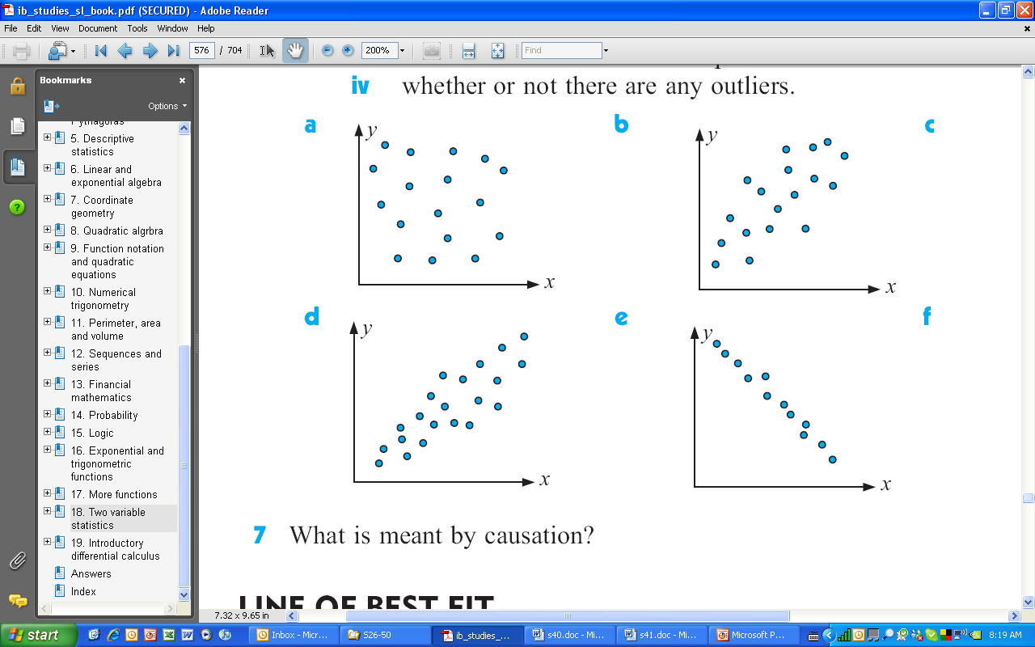 

III. IV.

 

2.

|  |  |  |
| --- | --- | --- |
| **name** | **Trig (x)** | **Geom (y)** |
| A | 31 | 29 |
| B | 52 | 46 |
| C | 83 | 71 |
| D | 67 | 31 |
| E | 74 | 58 |
| F | 46 | 42 |
| G | 79 | 71 |
| H | 48 | 39 |
| I | 91 | 82 |

The table on the left shows the percentage scores of 9 students in trigonometry and geometry tests.

(a) Plot these points on a scatter plot.

(b) One student was feeling very unwell during the geometry test. Which one would you expect this to be?

(c) Not counting the outlier you identified in part b, calculate  and  correct to the nearest integer.

(d) Plot the mean point (, ) on your graph and draw the line of best fit by eye, again ignoring the outlier.

(e) Describe the correlation between the trigonometry and geometry scores.

(f) Student J scored 60% in the trigonometry test. Estimate her score in the geometry test.

3. The table below gives information on two key indicators of human development for a selection of countries. The two indicators are **infant mortality** (per 1000 live births) and **life expectancy at birth** in years. We’ll abbreviate them to **IM** and **LEB**.

|  |  |  |
| --- | --- | --- |
| **country** | **IM (*x*)** | **LEB (*y*)** |
| Bangladesh | 64 | 62 |
| Bolivia | 55 | 65 |
| Brazil | 31 | 71 |
| Bulgaria | 21 | 72 |
| Cambodia | 74 | 58 |
| Chad | 95 | 48 |
| Denmark | 5 | 77 |
| Egypt | 34 | 71 |
| Japan | 3 | 81 |

(a) Using graph paper, plot these points on a scatter plot. *Start the y-axis at 40, not zero*.

(b) Calculate  and  correct to the nearest integer.

(c) Plot the mean point (, ) on your graph and draw the line of best fit by eye.

(d) In a phrase, describe the correlation between IM and LEB.

(e) In India the IM rate is 58. From your graph estimate what the LEB might be.

(f) The table below gives another indicator: gross domestic product (**GDP**) per capita at purchasing power parity in thousands of dollars. Use a scatter plot to investigate **either** the correlation of IM with GDP **or** the correlation of LEB with GDP.

|  |  |
| --- | --- |
| **country** | **GDP** |
| Bangladesh | 1.9 |
| Bolivia | 2.4 |
| Brazil | 7.6 |
| Bulgaria | 7.6 |
| Cambodia | 1.7 |
| Chad | 1.2 |
| Denmark | 31.2 |
| Egypt | 3.9 |
| Japan | 28.0 |