**Station 1**

**Evaluating Expressions and Solving Linear Equations**

1. **Evaluate each expression.**

a.  b.  when *x* = 3 and *y* = -2

c.  d.  when *m* = 3 and *p* = -4

1. **Solve each equation. Answers should be in simplest form.**
2.  b. 

c.  d. 

**Station 2**

**Solving for a Variable**

1. **Solve each equation for *y*. Answers should be in simplest form.**
2.  b. 

c.  d. 

1. **The formula for the volume of a cylinder is** . **Solve the formula for *h.* How tall is a cylinder with radius 3 centimeters and volume 200 cubic centimeters?**

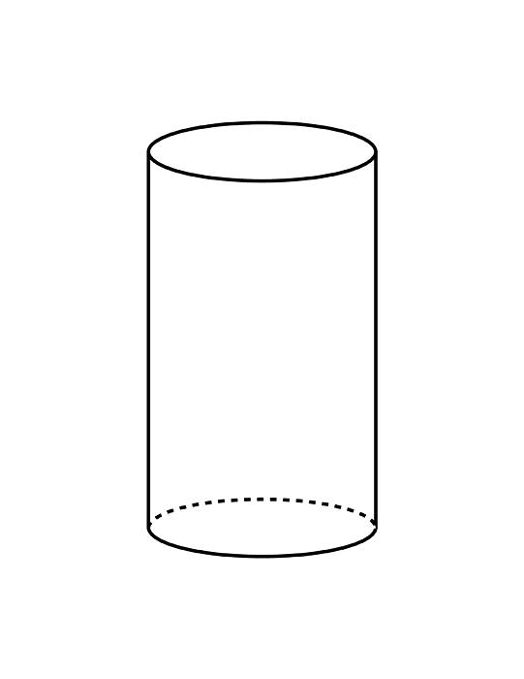

3

1. **The formula for the area of a triangle is** . **Solve the formula for *b.* What is the base of the triangle with an area of 30 inches and a height of 7 inches?**

7

**Station 3**

**Simplifying Radicals and Power of Exponents**

**1. Simplify the following radicals.**

|  |  |
| --- | --- |
|  |  |
|  |  |
|  |  |

**2. Simplify the following radicals.**

**a.  b.  c. **

**d.  e.  f. **

**g.  h.  i. **

**Station 4**

**Factoring**

**1. Factor out the Greatest Common Factor and write the expression in Factored Form.**

**a)** 4*x*2– 18*x GCF= _________* **b)** 3*x*4 + 6 *GCF= _________*

Factored Form = __________________Factored Form = ____________________

**c)** –8*x*2 +4*x* +2*GCF= _________* **d)** 3*a*3*b*2+ 9*ab3 GCF= _________*

Factored Form = _________________Factored Form = ____________________

**1. Factor by finding the difference between two squares.**

**a) x2 – 36 b) 49x2 - 1**

**3. Factor the quadratic equation.**

**a)** *x*2 – 6*x* - 27 **c)** *p*2 + 9*p* + 21

**b)** *c*2 – 11*c* + 28 **d)** *a*2 – 26*a* + 169

**Station 5**

**Linear Functions**

1**. Find the slope of the line through the given points. Then determine the relationship between the lines.**

1. (-2, -6) and (4, 6)
2. (5.5, 0.6) and (1.1, and 2.8)
3. Would the lines be parallel, perpendicular, or neither? Explain your reasoning.

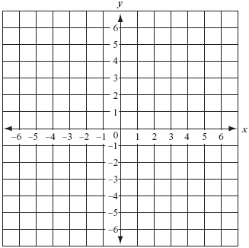**2. Given the equation of the line, determine the slope and y-intercept. Then graph the line.**



m = ______

b = ______

**3. Given the slope and point on a line, write the equation of the line.**

* Hint: You may use slope-intercept form (y = mx + b) or point-slope

form (y – y1) = m(x – x1).

Slope = -3, passes through (-2, -1)