Algebra 2 Name: _________________________________________
Homework - Systems of Equations in 2-variables

- Solve the following systems by graphing.

- x - y = - 2 2. x + y = - 3
x + y = 4 7x - y = - 3
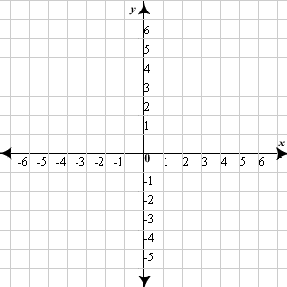

Solution: ____________________ Solution:______________

- Solve the following systems by using substitution.

- y = $\frac{1}{2}$ x -2 2. x + y = 1
-x - 6y = 4 2x + y = 5

- Solve the following systems by using elimination.

- -7x + 2y = 18 2. 7x + 2y = -19
6x + 6y = 0 -x + 2y = 21

- Steve and Jack are planning a super bowl party. There are 90 people going to the party, and each person will be given one gift: t-shirt or a football. The t-shirt costs $12 each, and the football costs $16 each. The budget for the gifts is $1344.

- Write an equation to represent the number of gifts given out.
- Write an equation to represent the amount that the gifts will cost.
- Solve the system algebraically
- How many t-shirts will be given away? How many footballs?

- Rafael’s DVD Rentals charges $4 a month for membership, plus $2 per movie rented. The Maeve Video store charges a flat of $10 per month for membership and movie rentals are free.

- Which company will give you a better deal for renting one movie a month? How about 4 movies?

- At how many movie rentals do the two companies cost the same amount?

