Name:________________________________________________________Date:__________________Block:______
IB MATH SL: Vectors day 2
Section 1 – Vector Subtraction
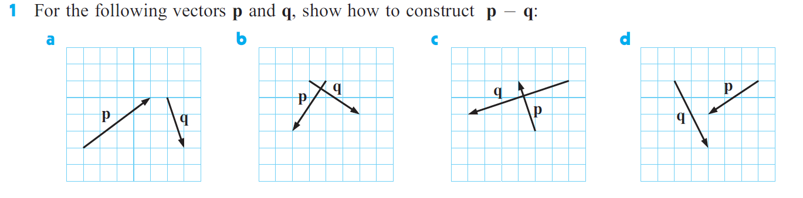
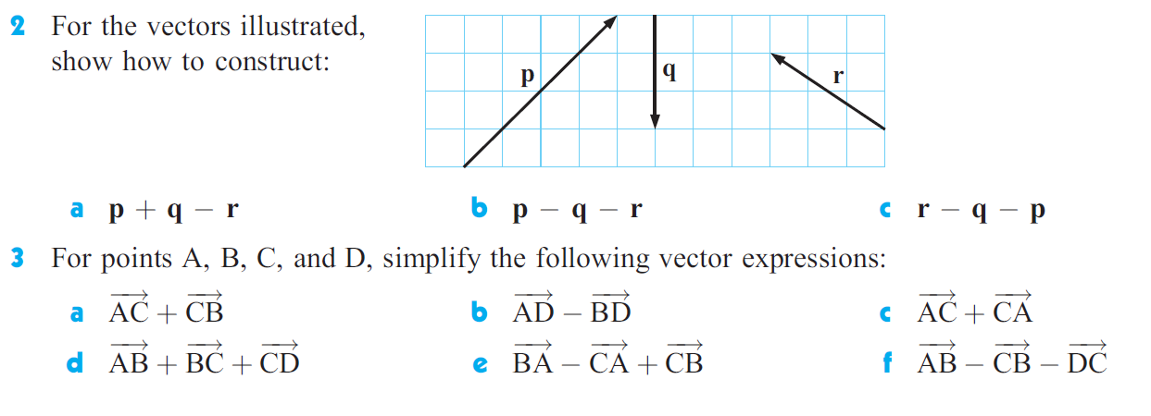
Section 2 – Vector Equations
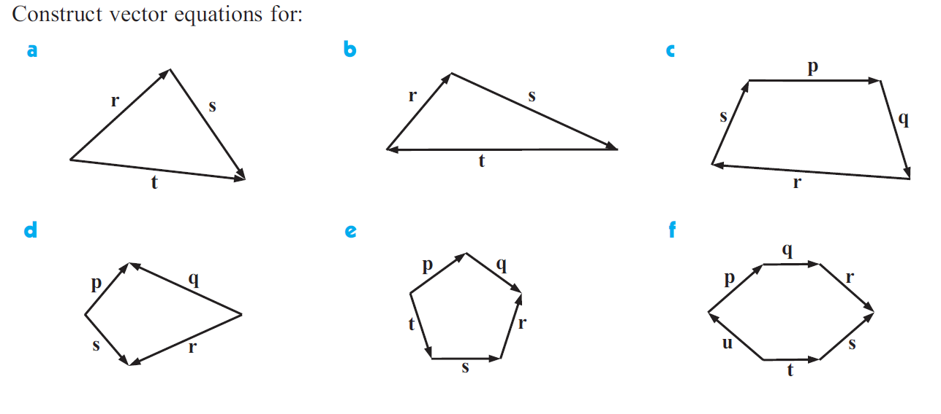
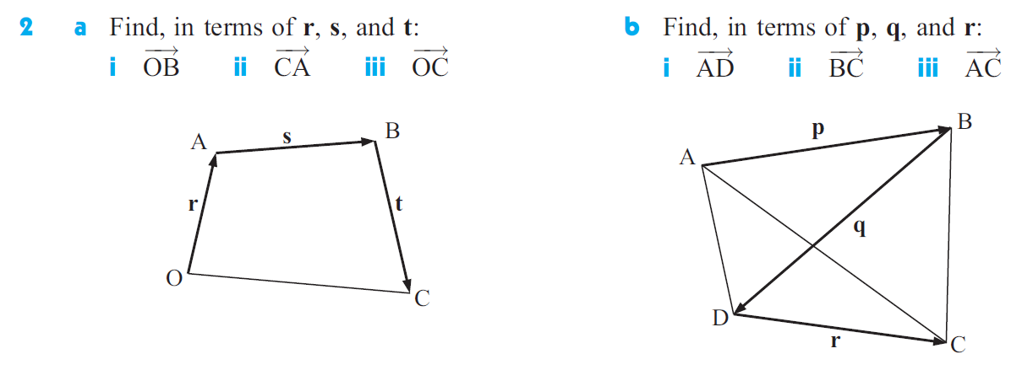
Section 3 – Scalar Multiplication
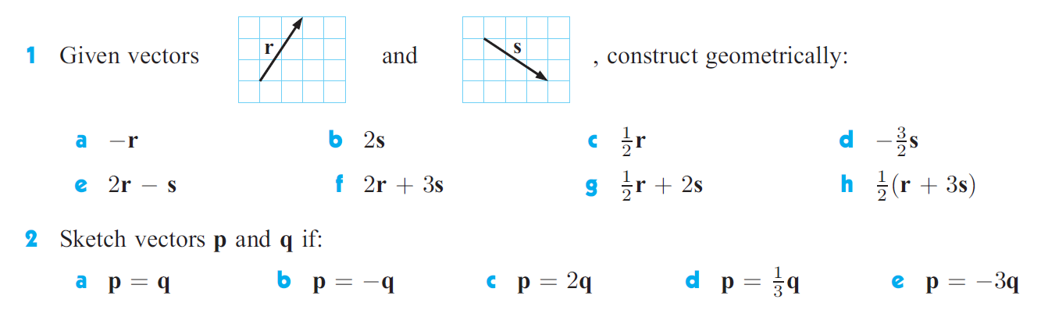
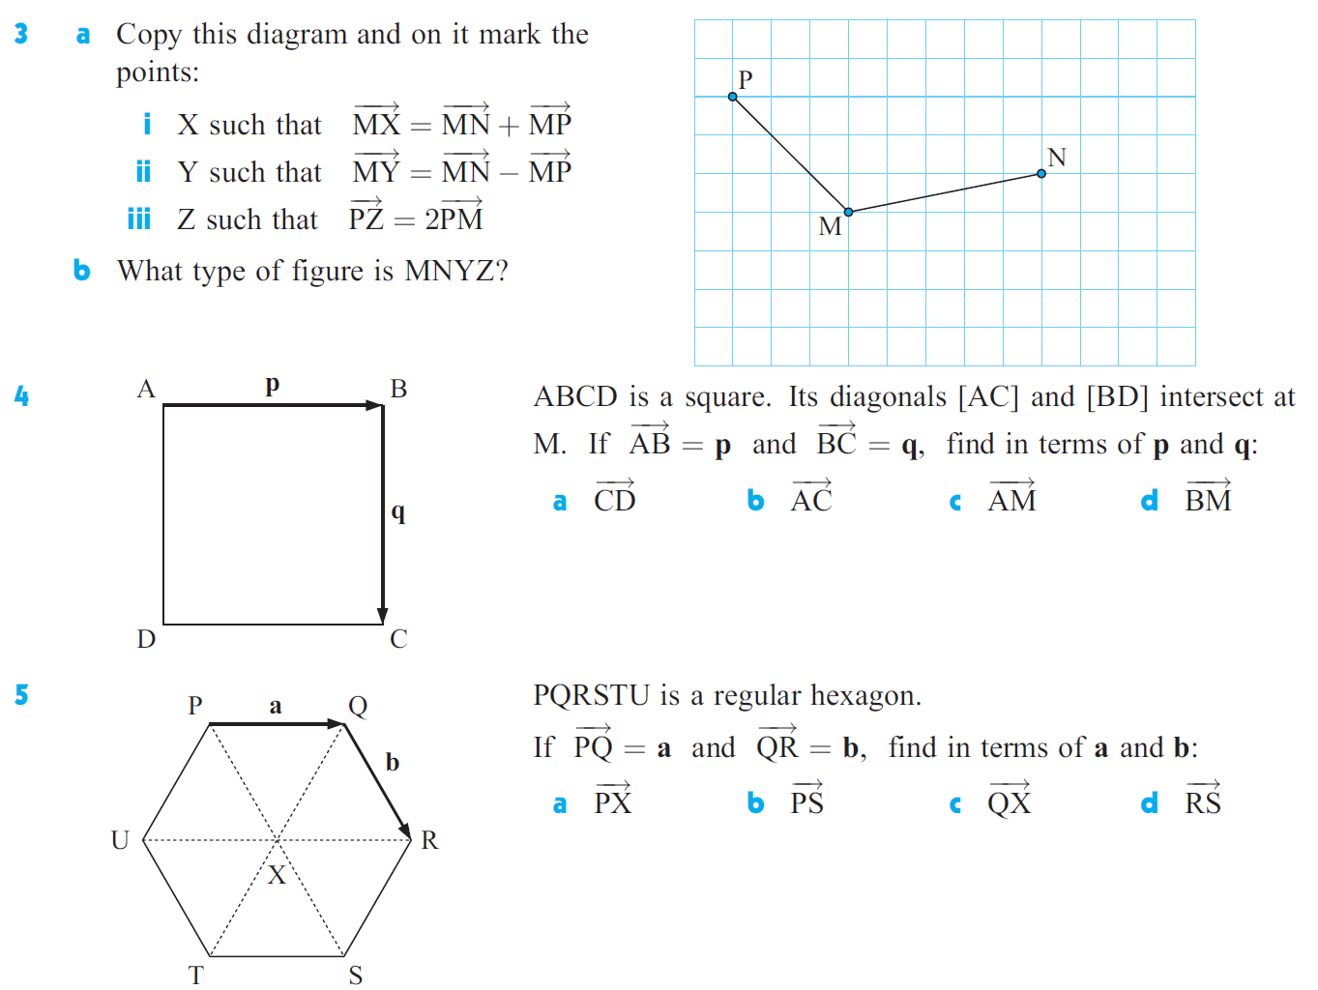

Section 4 – Unit Vectors
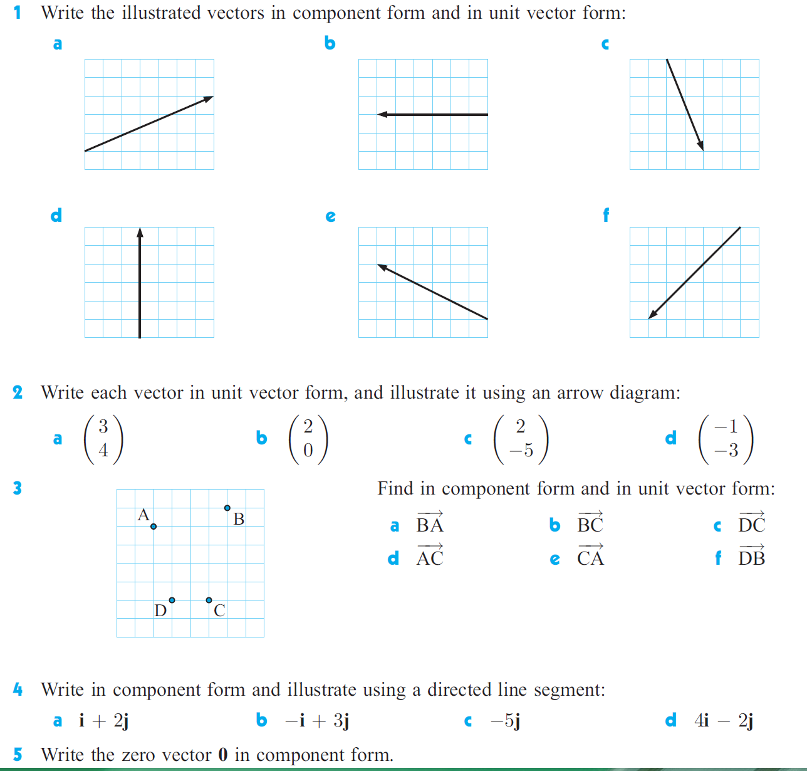

Section 5 – Magnitude
