Algebra 2 NAME:_________________________ DATE:_____________
CLASSWORK: Inverse Functions

1.) 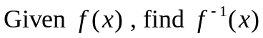

a. 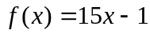 d. 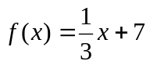

b. 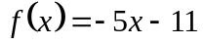 e. 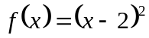

c. 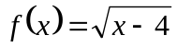

2.) Graph the inverse of the given function.

a. b.
( - 2 , - 4 ) ( 4 , 2 )
( 0 , 1 ) ( 2.5 , -2 )
( 2 , 6 ) ( - 1, - 5 )

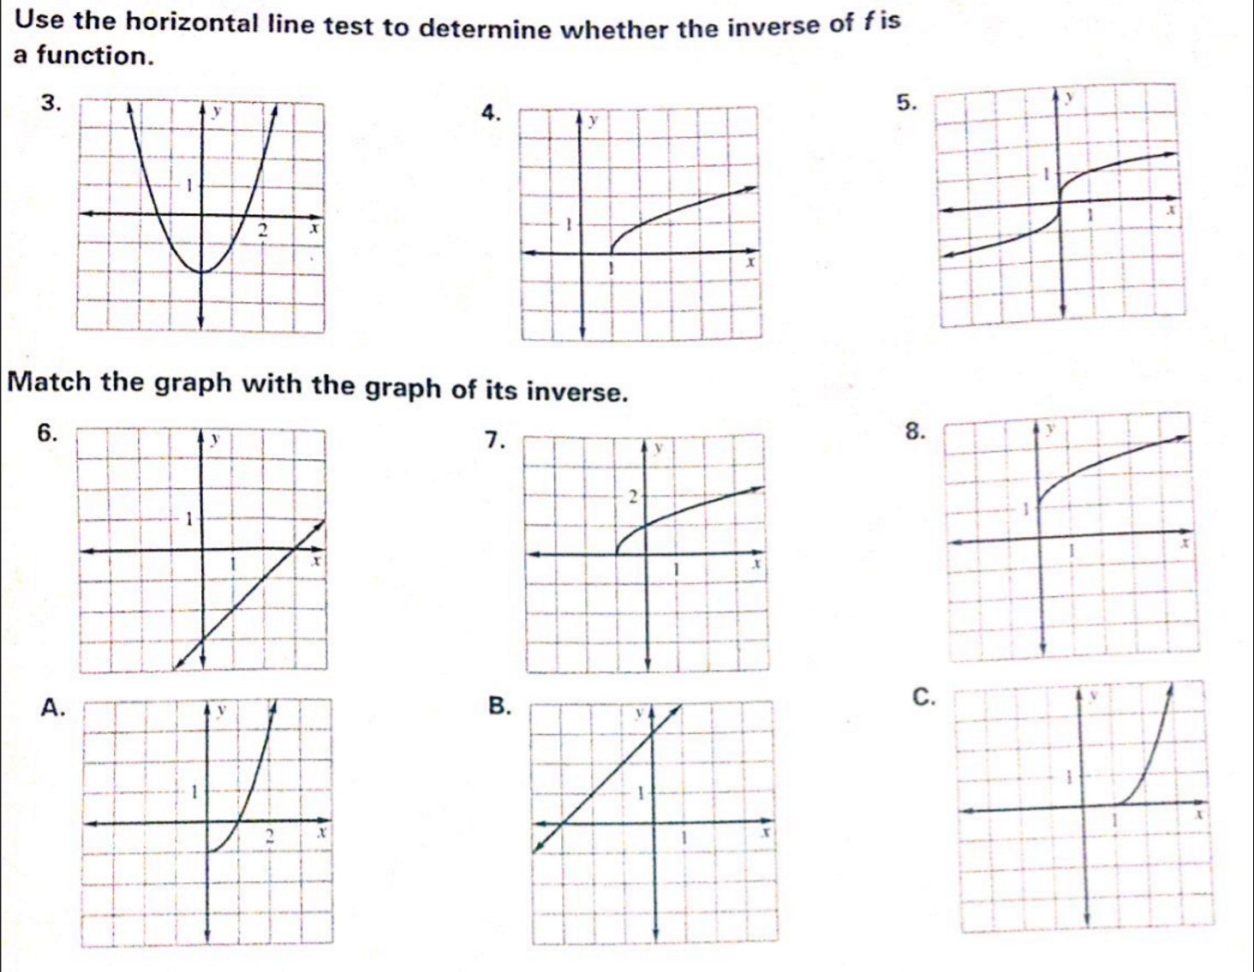

For #9-12, verify the f and g are inverse functions.

9.) 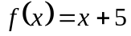, 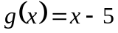 10.) 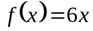, 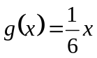

11.) 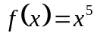, 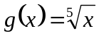 12.) 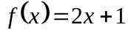 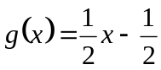

13. The formula 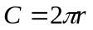gives the circumference of a circle of radius r. Write the inverse function, which gives the radius of a circle of circumference C. What is the radius of a circle with a circumference of 28 inches?

