Name__________________________________________________ Date__________
Stretching and Shrinking the Graph of f(x) = x²

1 EXAMPLE Graphing f(x) = ax² when |a| > 1
Graph each quadratic function using the same coordinate plane. (The graph of the parent function is shown.)
- A g(x) = 2x²
x | −3 | −2 | −1 | 0 | 1 | 2 | 3
g(x) = 2x²

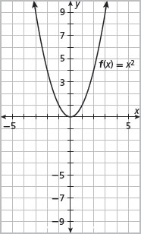
- 1a. In general, how does the y-coordinate of a point on the graph of g(x) = 2x²
compare with the y-coordinate of a point on the graph of f(x) = x² when the points
have the same x-coordinate?
__________________________________________________________
__________________________________________________________
- 1b. Describe the graph of g(x) = 2x² as a transformation of the graph of f(x) = x².
Use the word stretch in your description.
__________________________________________________________
- 1c. What transformation occurs when the value of a in g(x) = ax² is negative?
__________________________________________________________

EXAMPLE Graphing f(x) = ax² when |a| < 1
Graph each quadratic function using the same coordinate plane. (The graph of the parent function is shown.)
- A g(x) =  x −6 −4 −2 0 2 4 6  g(x) =  - B g(x) =  x −6 −4 −2 0 2 4 6  g(x) = | 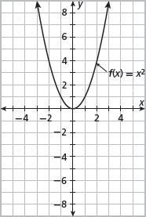
- 2a. Describe the graph of g(x) = as a transformation of the graph of f(x) = x². Use the word shrink in your description.
__________________________________________________________
- 2b. Compare the domain and range of g(x) = ax² when a > 0 and when a < 0.
__________________________________________________________
__________________________________________________________
- 2c. Summarize your observations about the graph of g(x) = ax² compared with the graph of f(x) = x².
Value of a | Vertical stretch or  shrink? | Reflection across x-axis?
a > 1
0 < a < 1
−1 < a < 0
a = 1
a < −1
Graphing Quadratic Functions in Vertex Form
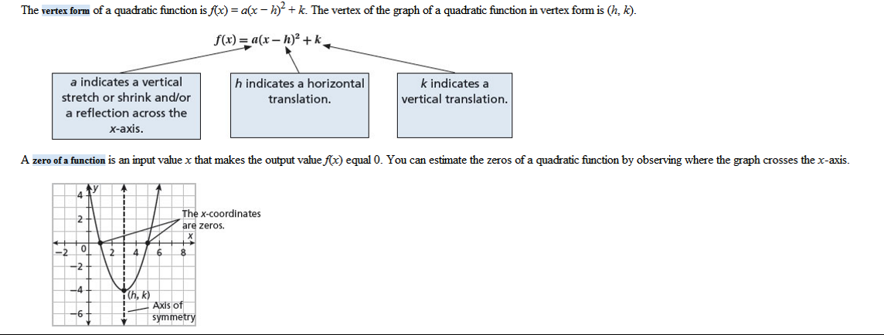
1a. For the function f(x) = 2(x − 3)² + 1, what are the values of a, h, and k? What do each of these values indicate about the graph of the function?
______________________________________________________________________
______________________________________________________________________
- 1b. If you estimate a zero of a quadratic function from a graph, how could you use algebra to check your answer?
______________________________________________________________________
______________________________________________________________________

2 EXAMPLE Graphing f(x) = a(x − h)² + k
Graph the function f(x) = 2(x + 1)² − 2. Identify the vertex, minimum or maximum, axis of symmetry, and zeros of the function.
- A Identify and graph the vertex.
h =
k =
The vertex of the graph is______________________.
- B Identify the coordinates of points to the left and right of the vertex.
x | −3 | −2 | 0 | 1
f(x)
C Graph the points and connect them with a smooth curve.
- D Identify the minimum or maximum.
The graph opens upward, so the function has a______________________.
The minimum is______________________.
- E Identify the axis of symmetry.
The axis of symmetry is the vertical line x =______________________.
- F Identify the zeros of the function.
The graph appears to cross the x-axis at the points ___________ and
___________, so the zeros of the function appear to be ___________ and ___________.

REFLECT
- 2a. How could you use the value of a to determine whether the function f(x) = 2(x + 1)² − 2 has a minimum or a maximum?
______________________________________________________________________
- 2b. How could you use the table in part B (or on your calculator) to confirm that you correctly identified the zeros of the function from its graph?
______________________________________________________________________

3 EXAMPLE Writing Equations in Vertex Form
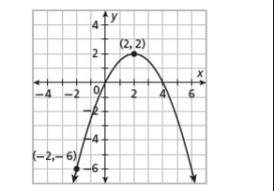
Write the vertex form of the quadratic function whose graph is shown.
- A Use the vertex of the graph to identify the values of h and k.
The vertex of the graph is___________.
h =
k =
Substitute the values of h and k into the vertex form:
f(x) = a (x − )² +
- B Use the point (−2, −6) to identify the value of a.
f(x) | = | a(x − 2)² + 2 |  | Vertex form
 | = | a( − 2)² + 2 |  | Substitute −6 for f(x) and −2 for x.
−6 | = | a( ) + 2 |  | Simplify.
 | = | a(16) |  | Subtract 2 from both sides.
 | = | a |  | Divide both sides by 16.
Substitute the value of a into the vertex form:
f(x) = (x − 2)² + 2
So, the vertex form of the function shown in the graph is
______________________.

PRACTICE
Graph each quadratic function. Identify the vertex, minimum or maximum, axis
of symmetry, and zeros of the function.
1. | f(x) = −2x² + 8 |  |  | 2. |  | f(x) = (x − 2)² − 4
 | 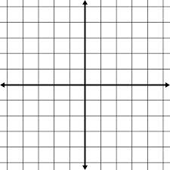
 | Vertex:  Min/Max:  AOS:  Zeros: |  |  | Vertex:  Min/Max:  AOS:  Zeros:
3. | f(x) = −(x + 4)² + 1 |  |  | 4. |  | f(x) = (x − 2)² – 3
 | Vertex:  Min/Max:  AOS:  Zeros: |  |  | Vertex:  Min/Max:  AOS:  Zeros:

5. | The function f(x) = −16(x − 1)² + 16 gives the height in feet of a football x seconds after it is kicked from ground level.  - a. Sketch a graph of the function.  - b. What is the maximum height that the ball reaches?  _________________________________________________________  - c. How long does the ball stay in the air? Explain how you determined your answer.  _________________________________________________________  _________________________________________________________  __________________________________________________________

6. | A technician is launching an aerial firework from a tower. The height of the firework in feet is modeled by the function f(x) = −16(x − 3)² + 256 where x is the time in seconds after the firework is launched.  - a. Sketch a graph of the function.  - b. Professional fireworks are usually timed to explode as they reach their highest point. How high will the firfirework be when it reaches its highest point?  __________________________________________________________  - c. What is the height of the tower from which the firework is launched? Explain how you determined your ananswer.

