Name_______________________________________________ Date_____________________
Algebra 2 – Graphing Absolute Value Function Practice A

Graph each equation. Identify the vertex of the graph, whether the graph opens up or down, and whether the graph is narrower or wider than $y=\left|x\right|$.
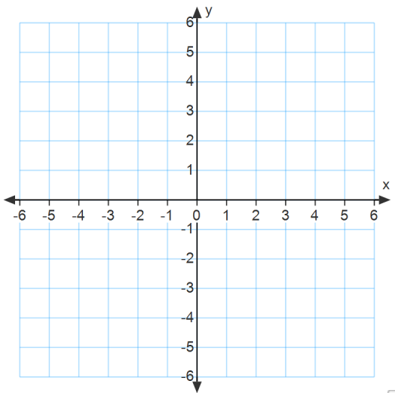
1) $y=\left|x-7\right|$ 2) $y=\left|x\right|+9$

3) $y=-\left|x-8\right|-1$ 4) $y=\frac{1}{3}\left|x-3\right|+4$

5) $y=-2\left|x+9\right|+3$

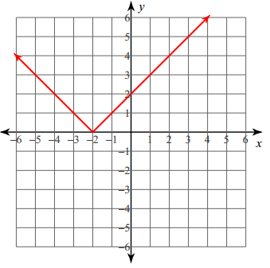
Write the equation for the graphs shown below.
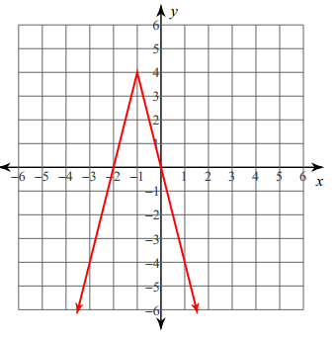
6) 7)

Complete the following.
8) One side of a sandwich lies on a coordinate grid. The lower left corner of the triangle is on the coordinate $(-4, -2)$ and the lower right corner of the triangle is on the coordinate $(4, -2)$. The top corner of the triangle has the coordinate $(0, 2)$. Assuming that the top corner is the vertex, what is the absolute value equation that connects the vertex to the bottom left and right corners?

9) An inverted triangular leaf blade lies on a coordinate grid. The upper left corner of the triangle is on the coordinate $(1,7)$ and the upper right corner of the triangle is on the coordinate $\left(5,7\right)$. The bottom corner of the triangle has the coordinate $\left(3,3\right)$.Assuming that the bottom corner is the vertex, what is the absolute value equation that connects the vertex to the top left and right corners?

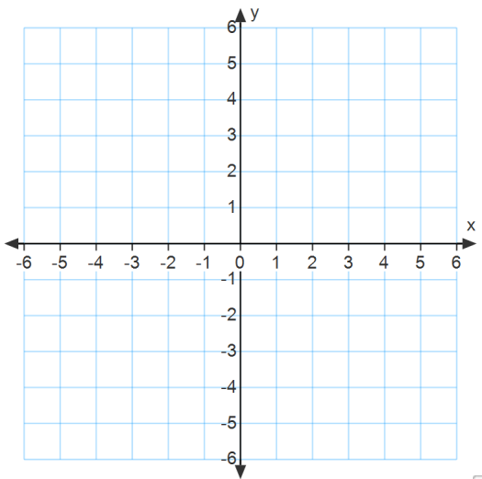
10) A rainstorm begins as a drizzle, builds up to a heavy rain and then drops back to a drizzle. The rate $r$ ( in inches per hour) at which it rains is given by the function $r=-0.5\left|t-1\right|+0.5$ where $t$ is the time (in hours).
a) Graph the function.

b) For how long does it rain and when does is rains the hardest?

