**Arithmetic Sequences Worksheet #1 Name: _______________________ Hr:____**

Write the equation for the arithmetic series below.

|  |  |  |
| --- | --- | --- |
| 1. | 2. 10, 100, 190, 280… | 3. |
| 4. 4, 1, -2, -5… | 5. | 6. 10, 8, 6, 4, …. |
| 7. | 8. | 9. |
| 10. | 11. | 12. |
| 13. | 14. | 15. |

16. Find  in # 1 17. Find  in # 2 18. Find  in #11.

19. Given . Find: d= _______.  

20. Write the first 5 terms of the sequence 

**Geometric Sequences Worksheet #1 Name: _______________________**

**Write the equation for the Geometric series below.**

|  |  |  |
| --- | --- | --- |
| **1. 4, 12, 36, 108, 324,…** | **2. 2, -6, 18,-54, 162,…** | **3. 2, 8, 32, 128,…** |
| **4. $\frac{1}{2}$, $\frac{1}{4}$, $\frac{1}{8}$, $\frac{1}{16} ,$…** | **5. 375, -75, 15, -3, …** | **6. -28, 14, -7, , - , …** |
| **7.** r = 3, a1 = 2 | **8.** r = -2, a1 = 6 | **9.** r = -3, a1 = 12 |
| **10.** a1 = , a3 = 6 | **, 11.**  a2 = 5, a4 = | **12.** a2 = 28, a5 = -1792 |

**Investigating Sums of Arithmetic Sequences**

STEP 1: **Add** the given terms of the sequence to find the sum for those terms.

STEP 2: **Calculate** the *average* of the first and last terms of the sequence.

STEP 3: **Multiply** the *average* found in step 2 by the number of terms in the sequence.

STEP 4: **Record** your answers in a table.

|  |  |  |  |
| --- | --- | --- | --- |
| Sequences | Sum | Average of  1st and last term | Multiply Avg. by number of terms |
| 2, 5, 8, 11, 14 |  |  |  |
| 1, 8, 15, 22 |  |  |  |
| -1, 1, 3 |  |  |  |
| 2, 11, 20, 29, 38, 47, 56 |  |  |  |
| -25, -29, -33, -37, -41 |  |  |  |
| 20, 16, 12, 8, 4, 0 |  |  |  |

**Draw Conclusions:**

1. Compare your answers from Steps 1 and 3. What do you notice?

1. Write a sentence that explains how to calculate the sum of the first n terms of a sequence

without adding all of the terms.

1. Write a formula for the explanations you gave in Exercise 3. Use **a1** to represent the first term,

**an** to represent the last term, and **n** to represent the number of terms.

5. Use your formula to find the sum of the terms in each of the following sequence:

a. 3, 9, 15, 21 b. 2, 3, 4, 5, 6, 7, 8, 9, 10, 11, 12, 13

**Arithmetic Series: Worksheet #2 Name:__________________________ Period:______**

Use the series formula and show your work.

Given the series 5, 8, 11, 14….

1. Find the sum of the first 4 terms. 2. Find .

Given the series 8, 7, 6, 5, 4, 3, 2….

3. Find the sum of the first 7 terms. 4. Find .

Given 

5. Find the sum of the first 12 terms. 6. Find the sum of the first 20 terms.

Given 

7. Find the sum of the first 9 terms. 8. Find the sum of the first 11 terms.

Given 

9. Find the sum of the first 99 terms. 10. Find the sum of the first 200 terms.

**Geometric Series: Worksheet #2 Name:__________________________ Period:______**

Use the series formula and show your work.

Given the series 1, 4, 16, 64, …

1. Find the sum of the first 14 terms. 2. Find *Sn* = 341

Given the series 7, -21, 63, -189, ….

3. Find the sum of the first 18 terms. 4. Find .

Given the series -90, 30, -10, 10/3, …

5. Find the sum of the first 16 terms. 6. Find *Sn* = -66.67

Given the series 1, 9, 81, 729

7. Find the sum of the first 10 terms. 8. Find the sum of the first 11 terms.

Given *an* =

9. Find the sum of the first 99 terms. 10. Find the sum of the first 200 terms. **Sigma Notation** Name:_______________________

Write the following in sigma notation.

1. 4, 8, 12, 16, 20, … 2. 20, 14, 8, 2, -4, -10, …

3. 10, 9, 8, 7, 6, 5, 4, 3, 2, 1,… 4. 5, 10, 15, …

5. 1, 2, 6, 24, 120, … 6. 81, 27, 9, 3, 1, …

7. -8, -12, -18, -27, … 8. 1, -6, 36, -216, …

Write out the series represented below.

7.  8.  9. 

10.  11.  12. 

13. 14. 15.

16. 17. 18.

Graphing Geometric Sequences Name:____________________

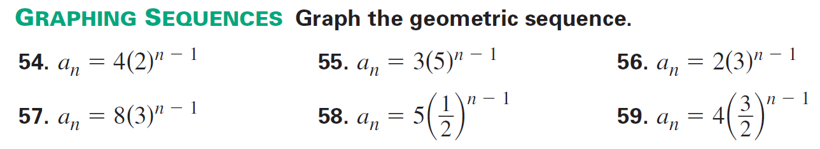

1. 2.

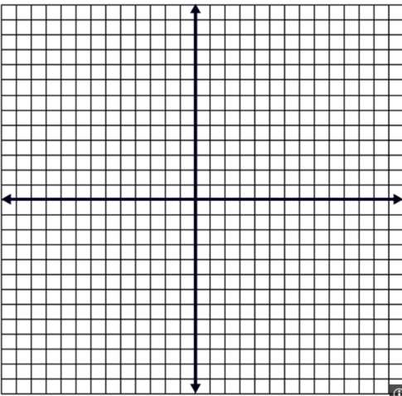 

3. 4.

 

5. 6.

 