Name____________________________________________________ Date________________
Applied Discrete Mathematics – Chapter 1 Review

For problems 1 and 2, make a reasonable conjecture for the next three numbers or letters in the sequence.
1) 3, 4, 6, 7, 9, 10, 12, 13, 15, 16, _____, _____, _______

2) 4, z, 16, w, 64, t, 256, _______, _______, ________

Make a reasonable conjecture and draw the next figure.
3)

Find a counter example to show that each statement is false.
4) The product of three odd numbers will always be even.

5) The sum of three multiples of 5 will always end in a 5.

Use inductive reasoning to find a rule that relates the number selected to the final answer and then try to prove your conjecture using deductive reasoning.
6) Select an even number:

Add 6:
Divide the answer by 2:
Add 10:
Result:

For problems 7-9, decide whether inductive or deductive reasoning was used.
7) My professor has given extra credit to his students for contributing canned goods to a food pantry during final week for the last 5 years, so I know I’ll get a chance for some easy extra credit on my final.

8) A GPA of 3.5 is required to make the dean’s list. I checked with all my teachers to see what my final grades will be, and my GPA works out to be a 3.72, so I’ll be on the dean’s list this semester.

9) To qualify for bowl games, college football teams have to win at least six games. Our team finished 5-7, so they won’t be playing in a bowl game this year.

Round each number to the place value given.
10) 132, 356 (thousands) 11) 14.63157 (ten-thousandths)

12) Estimate the cost of 5 textbooks if they cost $115.60, $89.95, $29.95, $62.50,and $43.10.

13) A car averages 14 miles per gallon of gas. Estimate how far the car can travel on 19 gallons of gas.

14) A video store sells used DVDs for $8.95, tax included. About how many could you buy with the $130 you got for selling your textbooks back?

15) Use the graph below to answer a and b.
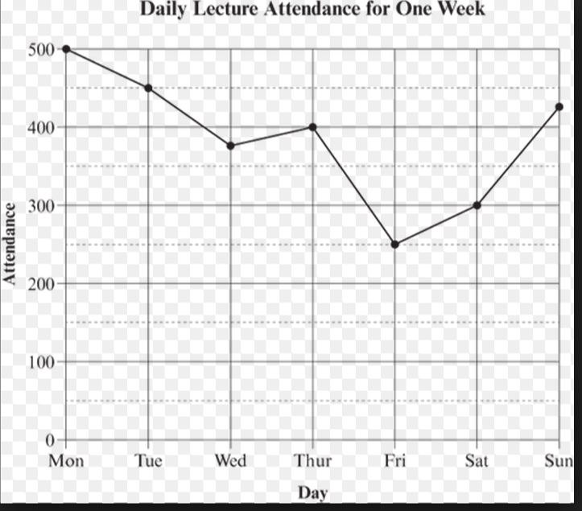

a) By about how much did attendance differ on Thursday and Sunday?

b) Estimate the total attendance on Friday, Saturday, and Sunday.

16) Can you divide a pie into 11 pieces with 4 straight cuts. The cuts must go from rim to rim but not necessarily through the center. The pieces need not be identical.

17) Tine and Joe are doing homework problems for their math class. Joe says to Tina, “If I do one more problem, then we’ll have both done the same number of problems”. Tina says to Joe, has each one done so far?

18) A small mocha latte and biscotti cost $3.40. If the mocha cost $0.40 more than the biscotti, how much did each cost?

19) In 20 years, Charlie will be 3 times as old as he is now. How old is he now?

20) Using +, -, and X make a true equation. Do not change the order of the digits.

2 9 6 7 = 17

