Fibonacci Spiral Project
DUE: Monday, November 3, 2014
Create a Fibonacci Spiral of your own! This is your chance to show your creativity and artistic talent. You can use any materials and unique ideas you have to create this project. There is no limit to the size, as long as it fits in the door. Make sure you follow the content guidelines below to receive full credit.
You must use a ruler, a pencil and a compass in order to accurately create the spiral. Failure to do so will result in point deduction. Also, your name, period, teacher’s name and the date must be on the back of your project. Do NOT put your name on the front of the project. Include the grading rubric on the back when turning in your final project.
Directions:
1. Get poster board, a pencil and a ruler. Make a mark 16cm down and 11cm in from the top. THIS IS YOUR STARTING POINT.
2. Draw two squares side by side. The starting point from #1 should be the top left corner of your left square. Use your ruler to make them 1cm x 1cm. (NOT INCHES!!)
3. Now make a 2 X 2 square on top of the first squares.
4. The 3x3 square goes to the right of the previous squares, followed by the 5x5 square the goes beneath them.
5. Each new iteration (step) of the Fibonacci sequence is put on the previous squares in a clockwise rotation. (for example, it goes top, right, bottom, left, top, right, bottom, left, and so on…)
6. You must have 8 iterations (rectangles) on your poster when you are done. (The 8th rectangle will go off the paper and that’s fine). Below are the first few:
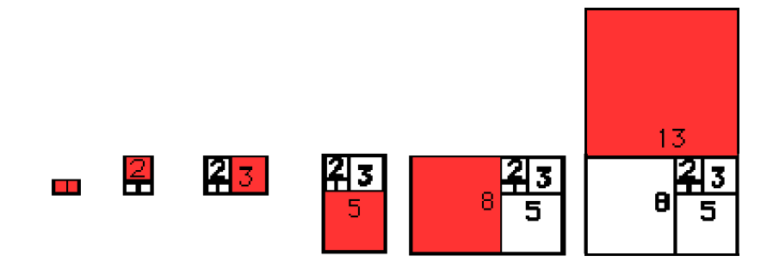
7. Using a compass, make an arc in the squares with a radius the size of the edge of the square. (for example, the compass for the first square should have a radius of 1cm. This will create an arc in each square that is one-quarter of a circle. It should look the spiral on the back of this sheet.
8. Color/decorate the spiral as creatively as you want!

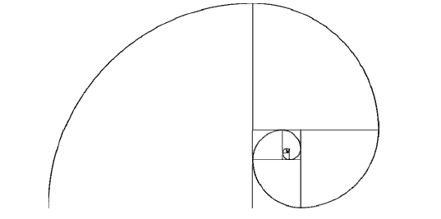

Name: __________________________________________ Period: _____________________Date:__________
ASI-11
Fibonacci Spiral Project
Grading Rubric

/8 | 8 squares for the first 10 iterations of the Fibonacci Sequence
/8 | Accurate measurements (using a ruler) for each of those squares (1 point each square)
/8 | Accuracy of the spiral in each of the squares (1 point each square)
/8 | Correct placement of each square (in a clockwise rotation) (1 point each square)
/8 | Originality/Creativity/Coloring
/5 | Neatness
/5 | Following guidelines of project
-5 | Not having Rubric
-5 | Lateness (each day)
/50 | TOTAL POINTS

