Name:___________________________________________________ Date:____________Block:______

**IB Math Studies**

**Topic: Quadratic Functions & Exponential Functions**

**1.** The graph of *y* = *x*2 – 2*x* – 3 is shown on the axes below.



(a) Draw the graph of *y* = 5 on the same axes.

(b) Use your graph to find:

(i) the values of *x* when *x*2 – 2*x* – 3 = 5

(ii) the value of *x* that gives the minimum value of *x*2 – 2*x* – 3

(Total 4 marks)

**2.** The figure below shows the graphs of the functions *f* (*x*) = 2*x* + 0.5 and *g* (*x*) = 4 − *x*2 for values of *x* between –3 and 3.



(a) Write down the coordinates of the points A and B.

(b) Write down the set of values of *x* for which *f* (*x*) *g* (*x*).

(Total 6 marks)

**3.** The perimeter of this rectangular field is 220 m. One side is *x* m as shown.



(a) Express the width (*W*) in terms of *x*.

(b) Write an expression, in terms of *x* only, for the area of the field.

(c) If the length (*x*) is 70 m, find the area.

(Total 4 marks)

**4.** The graph of a quadratic function *f* (*x*) intersects the horizontal axis at (1, 0) and the equation of the axis of symmetry is *x* = −1.

(a) Write down the *x*-coordinate of the other point where the graph of *y* = *f* (*x*) intersects the horizontal axis.

(b) *y* = *f* (*x*) reaches its maximum value at *y* = 5.

(i) Write down the value of *f* (−1).

(ii) Find the range of the function *y* = *f* (*x*).

(Total 6 marks)

**5.** The graph of the function *f : x * 30*x* – 5*x*2 is given in the diagram below.



(a) Factorize fully 30*x* – 5*x*2.

(b) Find the coordinates of the point A.

(c) Write down the equation of the axis of symmetry.

(Total 8 marks)

**6.** (a) Factorize 3*x*2 + 13*x* −10.

(2)

(b) Solve the equation 3*x*2 + 13*x* − 10 = 0.

(2)

Consider a function *f* (*x*) = 3*x*2 + 13*x* −10.

(c) Calculate the minimum value of this function.

(2)

(Total 6 marks)

**1.** The graph below shows the temperature of a liquid as it is cooling.



(a) Write down the temperature after 5 minutes.

(b) After how many minutes is the temperature 50°C?

The equation of the graph for all positive *x* can be written in the form *y* = 100(5–0.02*x*).

(c) Calculate the temperature after 80 minutes.

(d) Write down the equation of the asymptote to the curve.

(Total 8 marks)

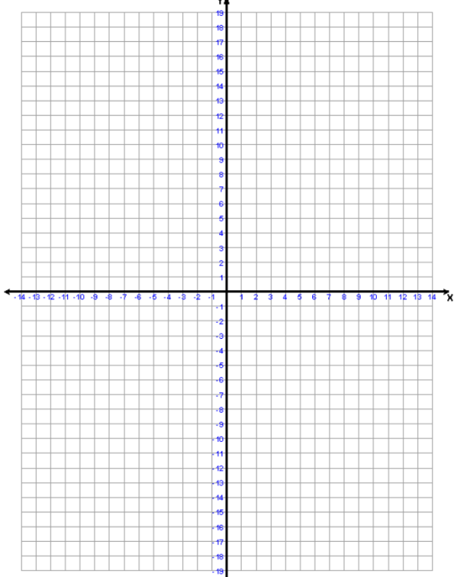

2. Graph the function $y= 2^{x}-3$ on an axis.

(a) The curve passes through the points (0, a) and (1, b).

Find the values of a and b.

(b) Find the equation of the asymptote of the curve.

3. The population of a rat colony is given by the formula $n=60(2^{0.3d})$, where n is the number of rats present in the colony and d is the number of days after the start of the experiment.

(a) Give the initial population of rats in the study.

(b) Complete the table below by finding values for a and b.

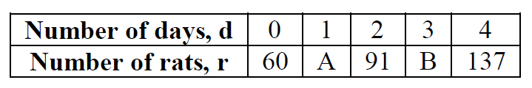

(c) On graph paper, represent the above function. Label the graph clearly.

(d) Use your graph to find the answers to the questions below. Clearly label how you found the answers on the graph.

i. How many rats are present after 2 days and 12 hours?

II. Approximately how many days will it take for the colony to have 120 rats?

4. The diagram below shows the curve $y= a^{x}+b$.

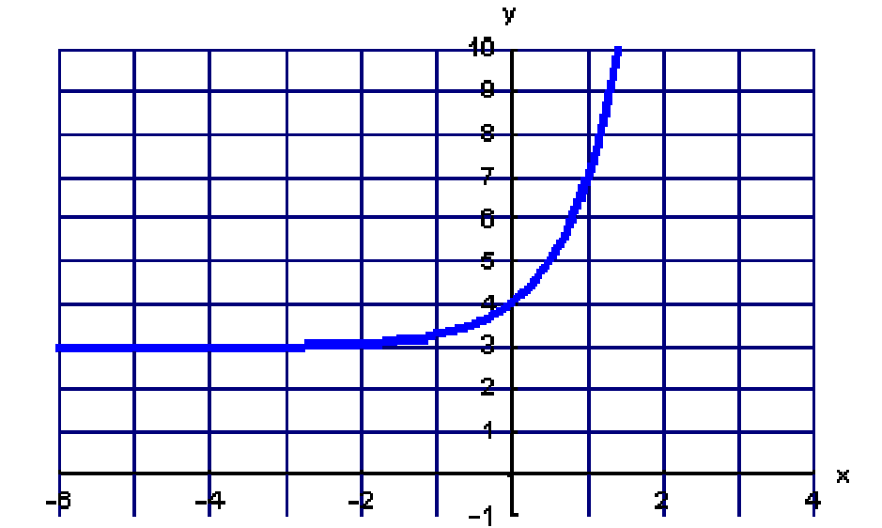

(a) The coordinate of the curve where it crosses the y-axis is (0 , P). Find the value of P.

(b) Use the graph to find the value of a in the equation.

(c) As x becomes a large negative number, explain what happens to the curve,

5. The amount of drugs present in the body, N, after time, t hours, is modeled by the equation $N=120× {0.5}^{t}$. Use this formula to calculate:

(a) The initial amount of drugs present.

(b) The amount of drugs present after 4 hours.

(c) The time taken for the amount of drugs to reduce to 1% of the original amount taken.

**6.** Eva invests USD2000 at a nominal annual interest rate of 8 % **compounded half-yearly**.

(a) Calculate the value of her investment after 5 years, correct to the nearest dollar.

Toni invests USD1500 at an annual interest rate of 7.8 % **compounded yearly**.

(b) Find the number of **complete** years it will take for his investment to double in value.

(Total 6 marks)

**7.** A basketball is dropped vertically. It reaches a height of 2 m on the first bounce. The height of each subsequent bounce is 90% of the previous bounce.

(a) What height does it reach on the 8th bounce?

(b) What is the total vertical distance travelled by the ball between the first and sixth time the ball hits the ground?

(Total 6 marks)

7. Consider the function *f*(*x*) = *x*3+ , *x* ≠ 0.

(a) Calculate *f*(2).

(2)

(b) Sketch the graph of the function *y* = *f*(*x*) for –5≤ *x* ≤ 5 and –200 ≤ *y* ≤ 200.

(4)

(c) Find *f*′(*x*).

(3)

(d) Find *f*′(2).

(2)

(e) Write down the coordinates of the local maximum point on the graph of *f.*

(2)

(f) Find the range of *f.*

(3)

**8.** A quadratic function, *f*(*x*)= *ax*2+ *bx*, is represented by the mapping diagram below.



(a) Use the mapping diagram to write down **two** equations in terms of *a* and*b*.

(2)

(b) Find the value of

(i) *a*;

(ii) *b*.

(2)

(c) Calculate the *x*-coordinate of the vertex of the graph of *f*(*x*).

(2)

(Total 6 marks)

**9.** A plumber in Australia charges 90 AUD per hour for work, plus a fixed cost. His total charge is represented by the cost function *C* =60 + 90*t*, where *t* is in hours.

(a) Write down the fixed cost.

(1)

(b) It takes  hours to complete a job for Paula. Find the total cost.

(2)

(c) Steve received a bill for 510 AUD. Calculate the time it took the plumber to complete the job.

(3)

(Total 6 marks)

**10.** The diagram below shows the line PQ, whose equation is *x* + 2*y* = 12. The line intercepts the axes at P and Q respectively.

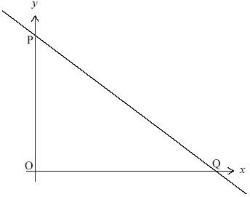

***diagram not to scale***

(a) Find the coordinates of P and of Q.

(3)

(b) A second line with equation *x* – *y* = 3 intersects the line PQ at the point A. Find the coordinates of A.

(3)

(Total 6 marks)

**5.** Given the function *f*(*x*) = 2 × 3*x* for –2 ≤ *x* ≤ 5,

(a) find the range of *f*;

(4)

(b) find the value of *x* given that *f*(*x*) = 162.

(2)

(Total 6 marks)

**6.** (a) Factorize the expression *x*2 – 3*x* – 10.

(2)

(b) A function is defined as *f* (*x*) = 1 + *x*3 for *x*, –3 *x* 3.

(i) List the elements of the domain of *f* (*x*).

(ii) Write down the range of *f* (*x*).

(4)

(Total 6 marks)

**7.** The function *f*(*x*) = *ax* + *b* is defined by the mapping diagram below.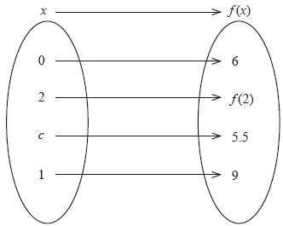

(a) Find the values of *a* and*b.*

(b) Write down the image of 2 under the function *f*.

(1)

(c) Find the value of *c*.

(2)

(Total 6 marks)

**8.** The following curves are sketches of the graphs of the functions given below, but in a different order. Using your graphic display calculator, match the equations to the curves, writing your answers in the table below.

***diagrams not to scale***

|  |  |  |
| --- | --- | --- |
|  | Function | Graph label |
| (i) | *y* = *x*3 + 1 |  |
| (ii) | *y* = *x*2 + 3 |  |
| (iii) | *y* = 4 − *x*2 |  |
| (iv) | *y* = 2*x* + 1 |  |
| (v) | *y* = 3−*x* + 1 |  |
| (vi) | *y* = 8*x* − 2*x*2 − *x*3 |  |



(Total 6 marks)

**9.** (a) *f* : *x* 3*x* − 5 is a mapping from the set *S* to the set *T* as shown below.



Find the values of *p* and *q*.

(2)

(b) A function g is such that *g* (*x*) = .

(i) State the domain of the function *g*(*x*).

(2)

(ii) State the range of the function *g*(*x*).

(1)

(iii) Write down the equation of the vertical asymptote.

(1)

(Total 6 marks)

**10.** The diagram shows a function *f*, mapping members of set A to members of set B.

(a) (i) Using set notation, write down all members of the domain of *f*.

(ii) Using set notation, write down all members of the range of *f*.

(iii) Write down the equation of the function *f*.

The equation of a function *g* is *g*(*x*) = *x*2 +1. The domain of *g*is .

(b) Write down the range of *g*.

(Total 6 marks)

**11.** The diagram below shows the graph of *y* = *c* + *kx* – *x*2, where *k* and *c* are constants.



(a) Find the values of *k* and *c*.

(b) Find the coordinates of Q, the highest point on the graph.

(Total 8 marks)

**12.** The diagrams below include sketches of the graphs of the following equations where *a* and*b* are **positive** integers.



Complete the table to match each **equation** to the correct **sketch**.

|  |  |  |
| --- | --- | --- |
|  | Equation | Sketch |
| (i) | *y* = *ax* + *b* |  |
| (ii) | *y* = –*ax* + *b* |  |
| (iii) | *y* = *x*2 + *ax* + *b* |  |
| (iv) | *y* = *x*2 – *ax* – *b* |  |

(Total 8 marks)

**13.** A student has drawn the two straight line graphs L1 and L2 and marked in the angle between them as a right angle, as shown below. The student has drawn one of the lines incorrectly.



Consider L1 with equation *y* = 2*x* + 2 and L2 with equation *y* = –*x* + 1.

(a) Write down the gradients of L1 and L2**using the given equations**.

(b) Which of the two lines has the student drawn incorrectly?

(c) How can you tell from the answer to part (a) that the angle between L1 and L2 should not be 90°?

(d) Draw the correct version of the incorrectly drawn line on the diagram.

(Total 8 marks)

**SOLUTIONS**

**1.** (a)

 (A1) (C1)

**Note:** The equation y = 5 is not required

(b) (i) *x* = –2, *x* = 4 (A1) (A1) (C2)

(ii) *x* = 1 (A1) (C1)

**Note:** Allow follow through from candidate’s graph

[4]

**2.** (a) A( –1.79, 0.789) and B(1.14, 2.70) (C2)(C2)

**Notes:** Award (C2) for each pair of coordinates obtained from the GDC

Award (A1)(A2)(ft) if bracket is not used.

(b) –1.79 *x* 1.14 (A1)(ft)(A1)(ft) (C2)

**Note:** Award (A1) for both numbers, (A1) for correct inequalities.

[6]

**3.** (a) 220 = 2(*W* + *x*) (M1)  
Therefore *W* =  or 110 – *x* (A1)

(b) Area = *x*(110 – *x*) *(allow follow through from part (a))* (A1)

(c) Area = 70(110 – 70) = 2800 m2*(allow follow through from part (b))* (A1)

[4]

**4.** (a) *x* = –3 (M1)(A1) (C2)

**Note:** Award (M1) for using property of symmetry or sketch.

(b) (i) *f*(–1) = 5 (A1) (C1)

(ii) Range = (–,5]or y  5 (A1)(A1)(A1) (C3)

**Notes:** Award (A1) for “ (–”, (A1) for “]”, (A1) for 5.

For y = 5 award (A1) only.

For y  5 award (A1)(A1).

[6]

**5.** (a) 5*x*(6 – *x*) (A1)(A1)(A1) (C3)

**Note:** Award (A1) for each factor. Therefore x(30 – 5x) would be awarded (A0)(A1)(A1).

(b) 5*x*(6 – *x*) = 0 (M1)  
*x* = 0 or *x* = 6  
*A* = (6, 0) (A1)(A1) (C3)

(c) *x* = 3 (A2) (C2)

**OR**

*x* =  (M1)  
 = 3 (A1) (C2)

[8]

**6.** *Unit penalty* (UP) *is applicable where indicated.*

(a) (3*x* – 2)(*x* + 5) (A1)(A1) 2

(b) (3*x* – 2)(*x* + 5) = 0

*x* =  or *x* = –5 (A1)(ft)(A1)(ft)(G2) 2

(c) *x* =  (A1)

Minimum*y* = 3

= −24.1 (A1) 2

[6]

**7.** (a) *f* (2) = 23 +  (M1)  
= 32 (A1)(G2)

(b)  
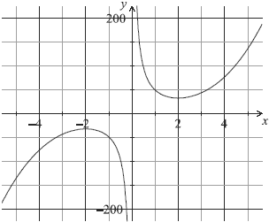  
(A1)for labels and some indication of scale in an appropriate  
window  
(A1)for correct shape of the two unconnected and smooth branches  
(A1)for maximum and minimum in approximately correct positions  
(A1)for asymptotic behaviour at *y*-axis (A4)

**Notes:** Please be rigorous.  
The axes need not be drawn with a ruler.  
The branches must be smooth: a single continuous line that does not deviate from its proper direction.  
The position of the maximum and minimum points must be symmetrical about the origin.  
The y-axis must be an asymptote for **both** branches. Neither branch should touch the axis nor must the curve approach the asymptote then deviate away later.

(c)*f*′(*x*) = 3*x*2 –  (A1)(A1)(A1)

**Notes:** Award (A1)for 3x2, (A1)for –48, (A1)for x–2.  
Award a maximum of (A1)(A1)(A0)if extra terms seen.

(d)*f*(2*)* = 3(2)2 –  (M1)

**Note:** Award (M1)for substitution of x = 2 into their derivative.

= 0 (A1)(ft)(G1)

(e)(–2,–32) or *x* = *–*2, *y* = –32 (G1)(G1)

**Notes:** Award (G0)(G0)for x = –32, y = –2  
Award at most (G0)(G1)if parentheses are omitted.

(f){*y*> 32}  {*y* < –32} (A1)(A1)(ft)(A1)(ft)

**Notes:** Award (A1)(ft)y **>**32 or y > 32 seen, (A1)(ft)for  
y ≤–32 or y < –32, (A1)for weak (non-strict) inequalities used in both of the above.  
Accept use of f in place of y. Accept alternative interval notation.  
Follow through from their (a) and (e).  
If domain is given award (A0)(A0)(A0).  
Award (A0)(A1)(ft)(A1)(ft)for [–200, –32], [32, 200].  
Award (A0)(A1)(ft)(A1)(ft)for ]–200, –32], [32, 200[.

**8.** (a) 4*a+* 2*b* = 20  
*a* + *b* = 8 (A1)  
*a* – *b* = –4 (A1) (C2)

**Note:** Award (A1)(A1) for any two of the given or equivalent equations.

(b) (i) *a* = 2 (A1)(ft)

(ii)*b* = 6 (A1)(ft) (C2)

**Note:** Follow through from their (a).

(c) *x* =  (M1)

**Note:** Award (M1) for correct substitution in correct formula.

= –1.5 (A1)(ft) (C2)

[6]

**9.** ***Note:Unitpenalty(UP)appliesinpart(c)***

(a) AUD 60 (A1) (C1)

(b) *C***=** 60 **+** 90(3.5) **=** AUD 375 (M1)(A1) (C2)

**Note:** Award (M1) for correct substitution of 3.5.

(c) 510 **=** 60 **+** 90*t* (M1)(A1)

**UP** *t***=** 5h (hours, hrs) (A1) (C3)

**Note:** Award (M1) for setting formula = to any number.  
(A1) for 510 seen.

[6]

**10.** (a) 0 **+** 2*y***=** 12 or *x* **+** 2(0) **=** 12 (M1)  
P(0, 6) (accept *x***=** 0, *y***=** 6) (A1)  
Q(12,0) (accept *x***=** 12, *y***=** 0) (A1) (C3)

**Notes:** Award (M1) for setting either value to zero.  
Missing coordinate brackets receive (A0) the first time this occurs. Award (A0)(A1)(ft) for P(0,12) and Q(6, 0).

(b) *x***+** 2(*x* – 3) **=** 12 (M1)  
(6, 3) (accept *x***=** 6, *y***=** 3) (A1)(A1) (C3)

**Note:** (A1) for each correct coordinate.  
Missing coordinate brackets receive (A0)(A1) if this is the first time it occurs.

[6]

**11.** (a) *f*(–2) = 2 × 3–2 (M1)  
 =  (0.222) (A1)  
*f*(5) = 2 × 35  
 = 486 (A1)  
Range  ≤ *f*(*x*) ≤ 486 **OR** (A1) (C4)

**Note:** Award (M1) for correct substitution of –2 or 5 into f(x), (A1)(A1)for each correct end point.

(b) 2 × 3*x* = 162 (M1)  
*x* = 4 (A1) (C2)

[6]

**12.** (a) (*x* − 5) (*x* + 2) (A1)(A1)

**Note:** Award (A1) for (x + 5)(x−2), (A0) otherwise.  
If equation is equated to zero and solved by factorizing  
award (A1) for both correct factors, followed by (A0). (C2)

(b) (i) −3, −2, −1, 0, 1, 2, 3 (A1)(A1)

**Notes:** Award (A2) for all correct answers seen  
and no others.  
Award (A1) for 3 correct answers seen. (C2)

(ii) −26,−7, 0, 1, 2, 9, 28 (A1)(A1)

**Notes:** Award (A2) for all correct answers seen  
and no others.  
Award (A1) for 3 correct answers seen.  
If domain and range are interchanged award  
(A0) for (b)(i) and (A1)(ft)(A1)(ft) for (b)(ii). (C2)

[6]

**13.** (a) *f*(0) **=***a*0*+ b***=** 6 (M1)  
*b***=** 5 (A1)  
*f*(1) **=***a*1 + 5 **=** 9 *a***=** 4 (A1) (C3)

**Note:** (M1) for attempt at solving any appropriate equations (simultaneously).  
(A1)(A1) for each correct answer.

(b) *f*(2) **=** 21 (A1)(ft) (C1)

**Note:** Follow through from their f(x)

(c) 4*c* + 5 **=** 5.5 (M1)

**Note:** Correct substitution in their f(x)

*c***=** (A1)(ft) (C2)

[6]

**14.** (i) B (A1)

(ii) D (A1)

(iii) A (A1)

(iv) E (A1)

(v) C (A1)

(vi) F (A1) (C6)

[6]

**15.** (a) *p =* –2 (A1)

*q =* 4 (A1) (C2)

(b) (i) domain = all real numbers except *x* = 2 (A1)(A1) (C2)

**Note:** (A1) for , (A1) for except x = 2, (or equivalent notation)

(ii) range*g*(*x*) > 0 (accept *y*> 0) (A1)

**OR**

(0, ) (A1)

**OR**

0,  (A1) (C1)

**Note:** Accept 0 < y 

(iii) *x* = 2 (A1) (C1)

**Note:** must be an equation with x

[6]

**16.** (a) (i) {–3, –2, –1, 0, 1, 2, 3} (A1)(A1)

**Notes:** Award (A1) for set brackets.  
Award (A1) for all and only correct numbers.

(ii) {0, 1, 4, 9} (A1)

**Notes:** Award (A1) for all and only correct numbers.  
If domain and range reversed, can follow through in (ii).

(iii) *f*(*x*) = *x*2 (A2) (C5)

**Note:** Allow any other rule that works.

(b) [1, ) or {*x*⇦*x* 1} (A1) (C1)

[6]

**17.** (a) *y* = *x*(5 – *x*) or *y* = 5*x* – *x*2 or 25 = *c* + 5*k* (M1)  
*c* = 0, *k* = 5 (A1)(A1) (C3)

**Note:** Award (A1) if no method is indicated but c = 0 or k = 5 is given alone.

(b) Vertex at *x* = = 2.5 (M1)(A1)  
*y* = 5(2.5) – 2.52 = 6.25 (M1)(A1)

**Note:** The substitutions must be attempted to receive the method marks.

Q(2.5, 6.25) (A1) (C5)

**Notes:** Coordinate pair is required for (A1) but Q is not essential. If no working shown and answer not fully correct, award (G2) for each correct value and (A1) for coordinate brackets. However, if values are close but not exactly correct (eg (2.49, 6.25)) award only (G1) for each less precise value. In this case AP might also apply if number of digits is inappropriate.  
If differentiation is used, award (M1) for correct process, (A1) for x = 2.5, (M1)(A1) or (G2) for 6.25 and (A1) for coordinate brackets.

[8]

**18.**

|  |  |  |  |
| --- | --- | --- | --- |
| equation | sketch |  |  |
| (i) | 2 | (A2) |  |
| (ii) | 4 | (A2) |  |
| (iii) | 3 | (A2) |  |
| (iv) | 1 | (A2) | (C8) |

**Note:** Award (A2) for each correct sketch.

[8]

**19.** (a) L1 has gradient 2 and L2 has gradient . (A1)(A1) (C2)

**Note:** Award (A0)(A1)**ft** if the order of the gradients is reversed **or both** signs are wrong **or both** are reciprocals of the correct answer.

(b) L2 is drawn incorrectly. (A2) (C2)

(c) The product of the gradients is 2 ×  –1. (M1)(A1) (C2)

**Note:** Award (M1) for looking at product of gradients,  
 (A1) for comparing something to –1.

(d) The drawing should show a straight line passing through  
*x* and *y* intercepts at (4, 0) and (0, 1) respectively. (A1)(A1) (C2)

**Note:** Award (A1) for each intercept. If these are wrong but gradient is  then (A1).If correct line is very poorly drawn then (A1).

[8]