**Algebra 2 Name   
Summer Quiz Review Date Block**

1. **Evaluate each expression.**

a.  b.  when *x* = -5 and *y* = 1

1. **Solve each equation. Answers should be in simplest form.**
2.  b. 
3. **Solve each equation for *y*. Answers should be in simplest form.**
4.  b. 
5. **The formula for the perimeter of a rectangle is **
6. **Solve the formula for *w.***
7. **What is the width of a rectangle with a Perimeter of 46 and a length of 16?**

5. **Express the following in simplest radical form.**

a. $\sqrt{12}$

b. $\sqrt{\frac{5}{9}}$

**6. Simplify each expression. Answers should be written using positive exponents.**

a. $\frac{a^{4}}{a^{1}}$

b. $v^{7}∙v^{2}$

c. ${\left(t^{5}\right)}^{3}$

**7. Factor out the Greatest Common Factor and write the expression in Factored Form.**

$5x^{2}+20x$ GCF___________________

Factored Form___________________

**8. Evaluate the function for the given value of *x*.**

 when x = 6

**9. Find the slope of the line through the given points. Then determine the relationship between the lines.**

1. (4.5, -5) and (1, 2)
2. (-2, 5) and (1, -1)

c. Is the line in part a rising, falling, horizontal, or vertical?

d.Would the lines in parts a and b be parallel, perpendicular, or neither? Explain your reasoning.

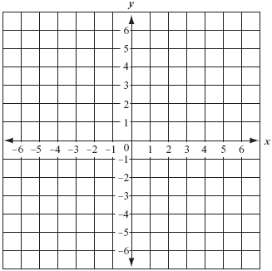**10. Given the equation of the line, determine the slope and y-intercept. Then graph the line.**



m = ______

b = ______