Name: ________________________________________________ Date: __________ Block:__________
IB Math Studies
Solve Systems of Equations

1. At Jumbo’s Burger Bar, Jumbo burgers cost $J each and regular cokes cost $C each. Two Jumbo burgers and three regular cokes cost $5.95.

a) Write an equation to show this.

b) If one Jumbo Burger costs ₤2.15, what is the cost of one regular coke?

2. Solve the following system of equations by:
$$3x-5y=11$$
$$4x+3y=5$$

- Graphing

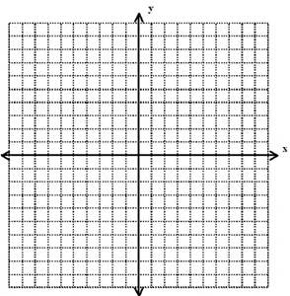

- Elimination

- Substitution

3. Solve the following system of equations by:
$$3x-2y=16$$
$$y=2x-10$$

- Graphing

- Elimination

- Substitution

