Name: ______________________________________________________Date:________Block:_____
IB Math SL - Vector Applications Practice
4a. The following diagram shows the cuboid (rectangular solid) OABCDEFG, where O is the origin, and 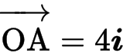 , 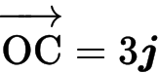 , 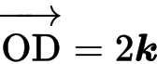 .
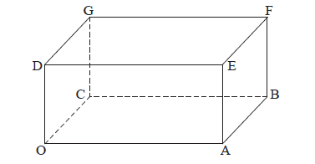
(i) Find 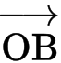 .
(ii) Find 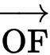 .
(iii) Show that 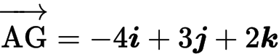 .
[5 marks]
4b. Write down a vector equation for
(i) the line OF;
(ii) the line AG.
(ii) any correct equation for (AG) in the form 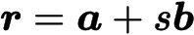 A2 N2

[4 marks]

4c. Find the obtuse angle between the lines OF and AG.

[4 marks]
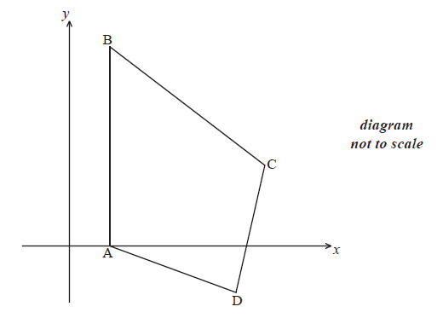
5a. The diagram shows quadrilateral ABCD with vertices A(1, 0), B(1, 5), C(5, 2) and D(4, −1) .

(i) Show that 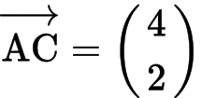 .
(ii) Find .
(iii) Show that 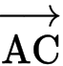 is perpendicular to .
[5 marks]

5b. The line (AC) has equation .
(i) Write down vector u and vector v .
(ii) Find a vector equation for the line (BD).
[4 marks]

5c. The lines (AC) and (BD) intersect at the point 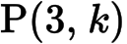 . Show that .
[3 marks]

5d. The lines (AC) and (BD) intersect at the point . Hence find the area of triangle ACD.
[5 marks]
6a. [4 marks]
The line 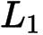 passes through the points P(2, 4, 8) and Q(4, 5, 4) .
(i) Find .
(ii) Hence write down a vector equation for in the form .

6b. [7 marks]
The line 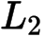 is perpendicular to , and parallel to 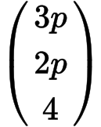 , where 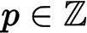 .
(i) Find the value of p .
(ii) Given that passes through 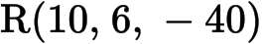 , write down a vector equation for .

6c. [7 marks]
The lines 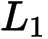 and 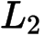 intersect at the point A. Find the x-coordinate of A.

7a. [3 marks]
The following diagram shows the obtuse-angled triangle ABC such that 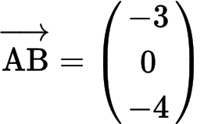 and 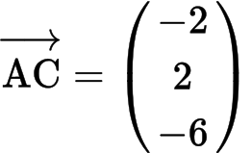 .
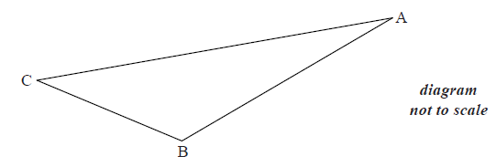
(i) Write down .
(ii) Find .
7b. [7 marks]
(i) Find .
(ii) Hence, find .
7c. [6 marks]
The point D is such that 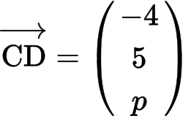 , where 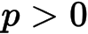 .
(i) Given that 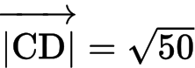 , show that 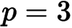 .
(ii) Hence, show that 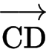 is perpendicular to .

9a. [5 marks]
The diagram shows a parallelogram ABCD.
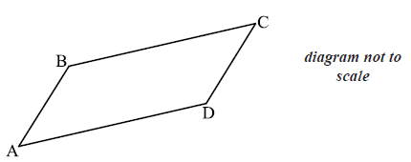
The coordinates of A, B and D are A(1, 2, 3) , B(6, 4,4 ) and D(2, 5, 5) .
(i) Show that 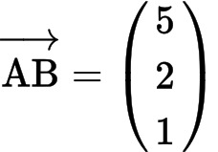 .
(ii) Find .
(iii) Hence show that 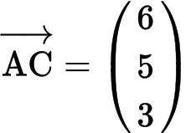 .
9b. [3 marks]
9c. [7 marks]
(i) Find 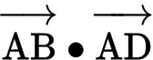.
(ii) Hence find angle A.
9d. [3 marks]
Hence, or otherwise, find the area of the parallelogram.

10a. [4 marks]
In this question, distance is in metres.
Toy airplanes fly in a straight line at a constant speed. Airplane 1 passes through a point A.
Its position, p seconds after it has passed through A, is given by 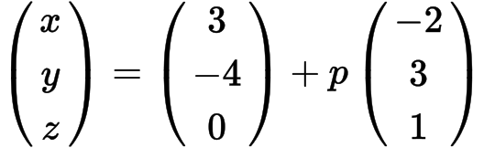 .
(i) Write down the coordinates of A.
(ii) Find the speed of the airplane in 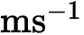.
10b. [5 marks]
After seven seconds the airplane passes through a point B.
(i) Find the coordinates of B.
(ii) Find the distance the airplane has travelled during the seven seconds.
10c. [7 marks]
Airplane 2 passes through a point C. Its position q seconds after it passes through C is given by 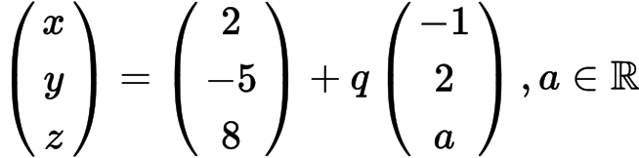 .
The angle between the flight paths of Airplane 1 and Airplane 2 is 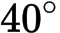 . Find the two values of a.

