Name: ________________________________________________ Date: ___________ Block: __________

***Algebra 2***

***Parent Functions & Transformations***

**For problem 1- 8, please give the name of the parent function and describe the transformation represented. You may use your graphing calculator to compare & sketch.**

1. g(x) = x 2 – 1 **2.** f(x) = 

Parent: _________________ Parent: _________________

Transformations:__________ Transformations:__________

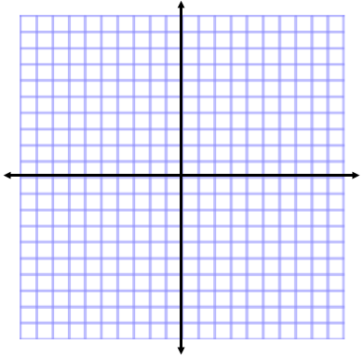 

**3.** h(x) =  **4.** g(x) = -2(x+1)2 + 3

Parent: _________________ Parent: _________________

Transformations:__________ Transformations:__________

 

**5.** g(x) =  **6.** f(x) =  - 2

Parent: _________________ Parent: _________________

Transformations:__________ Transformations:__________

 

**7.** h(x) =  **8.** g(x) = 

Parent: _________________ Parent: _________________

Transformations:__________ Transformations:__________

 

**For problems 9 – 14, given the parent function and a description of the transformation, write the equation of the transformed function, f(x).**

**9.** Absolute value—vertical shift up 5, horizontal shift right 3. ___________________________________

**10.** Cosine function – vertical shift down 4. ________________________________________

**11.** Linear—vertical stretch/compression by ________________________________________________

**12.** Root —flipped over the x axis, vertical shift down 2._________________________________________

1. Exponential—vertical stretch by 8 ________________________________________________________
2. Quadratic—vertical stretch by 5, horizontal shift left 8.________________________________________
3. Which graph best represents the function f(x) = 2x2 - 2?

a. b. c. d.

