Name_______________________________________________________ Date_____________
IB Math Studies – Set Operations, De Morgan’s Laws and Venn Diagrams

For problems 1- 4, use the information below.
$$U=\left\{20, 40, 60, 80, 100,110\right\}$$
$$A=\left\{20, 60, 100,110\right\}$$
$$B=\left\{60, 80,100\right\}$$
$$C=\{80, 100,110\}$$
1) $A-B$ 2)$B-C$

3) $A-C$ 4) $B-A$

For problems 5 – 8, draw a Venn diagram and shade the sections representing each set.
5) $A∪B'$ 6) $(A∪B)'$

7) $A'∪B$ 8) $A∩B'$

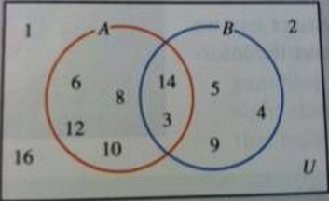
For problems 9 and 10, use the following Venn Diagram to find the cardinality of each set.

9) $n(A)$ 10) $n(A∩B)$

11) $n(A∪B)$ 12) $n(A^{'})$

For problems 13 -16, use the following information. Note that A and B are subsets of the Universal set U.
$$U=\left\{x | x is a natural number<13\right\}$$
$$A=\left\{x \right|x is an odd natural number\}$$
$$B=\left\{x \right|x is a prime number\}$$
(Hint: The prime numbers less than 13 are 2, 3, 5, 7 and 11.)

13) $n(A)$ 14) $n(B)$

15) $n(A∩B)$ 16) $n(A∪B)$

